**Homepage content**

***Button:* What we do**

*Directs to: “What we do” page*

Copy (above or below button): We are housing experts, here to help the people of Bristol and beyond navigate the path to a safe and secure home.

Established in 1965, we give clients the advice, support, and advocacy they need to avoid or escape homelessness and find long-term stability.

We have a strong focus on areas of high socio-economic deprivation.

We believe that housing is a human right, and we fight tirelessly for everyone to have a safe, secure home.

***Button:* Get Help**

Copy (above or below button): “Are you currently homeless, threatened with homelessness or in housing stress? Find out about the different ways you can access our advice and support services.”

Directs to: page currently titled “Get in touch”. Can see you’ve already included the correct content:

* Advice line and advice inbox information and HM postal address
* Link to drop-in page with short overview of drop-ins (incorporated into the banner that you’ve already got on the wireframe): “Are you looking for face-to-face support on dealing with your housing issues or the cost-of-living crisis? Head to one of our drop-in advice sessions around Bristol. All sessions are free, confidential and one-to-one. Find your nearest here.” [link to drop-in page]
* “For no-nonsense guides on common housing issues, check out our Housing Helpsheets” [link to helpsheet page]

***Button:* Donate**

Directs to: Donate page

***Button:* Find out more**

Copy (above or below button): “Sign up now to find out more about what we’re doing to prevent in Bristol”

Directs to: Then this can go straight to [this landing page](https://housingmatters.org.uk/lets-prevent-homelessness/)

**About us**

So on the nav bar, there will be a drop-down with all of the headings currently on this page?

And then this page will still exist if you just click on the “about us” item?

Can we exclude "our impact", "helpful resources" and "Get in touch" seeing as they're already in the nav bar?

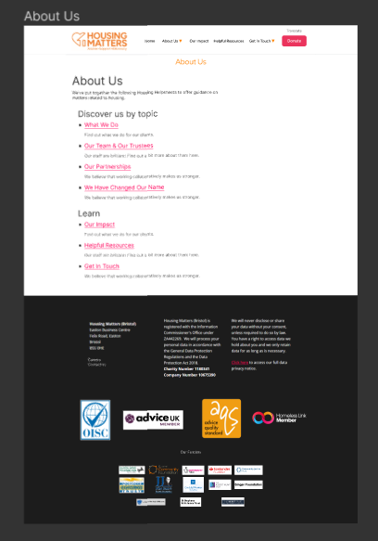

**Our impact**

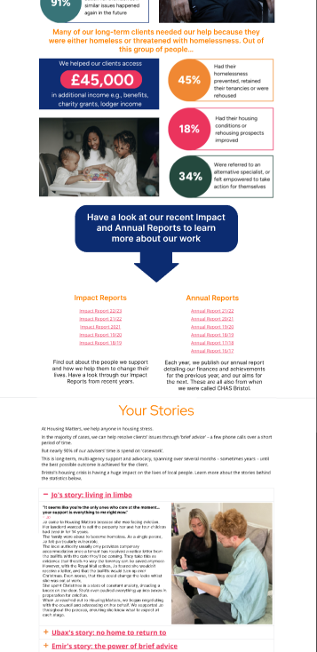

I think that case studies are really important to each audience – could they have their own tab in the nav bar? I would be worried they’d get missed here.

On Figma, the teams/Trustees and partnerships pages are in the “Our Impact” column... is this just whilst you’re working on the wireframe still rather than them being included as part of our impact?

**Helpful resources**

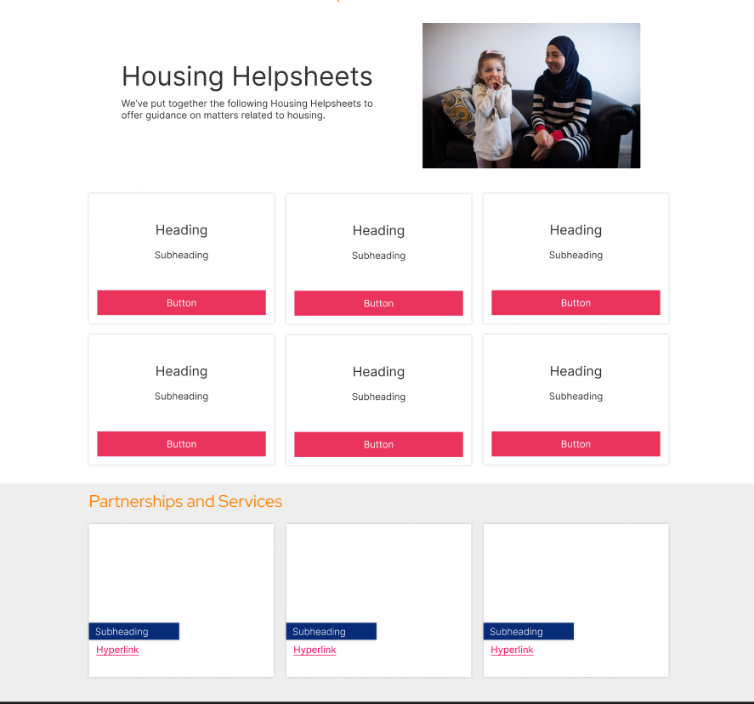

Under the “partnerships and services heading”, are you planning to include our partners’ web pages or would this link to our own “Our Partnerships” page?

**Drop-in page**

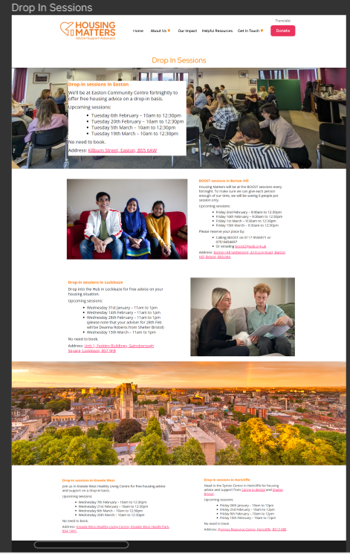

Not sure if this page is finished but at the moment, but it looks like the Hartcliffe and Knowle West drop-ins are separate from or less important than the other ones. Please can you move them above the banner with the photo of Bristol?

Could you remove the top banner? I think it looks a bit cluttered with the text box within it. Also the photo is of a workshop made up of professionals. Clients get worried about the drop-in sessions not being one-to-one or confidential, and I think this image makes the sessions look like group support sessions.

**Donate page**

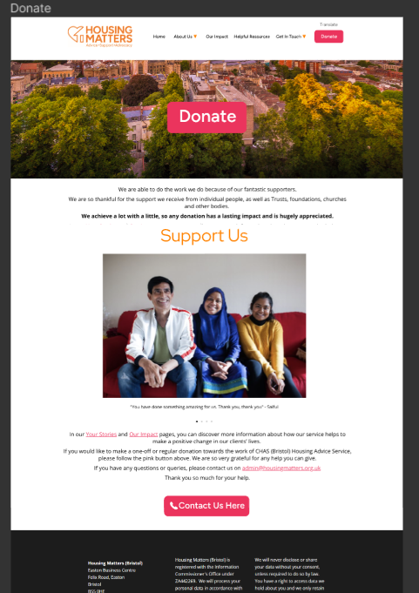

THe first thing I see on this page is the contact us button rather than the donate button. It would give me the impression that you need to contact Housing Matters to make a donation. Could the second button be a donate button as well as the top button?

**Colour hierarchy**

H1 - #FF8200 (brand orange)

H2 - #FF8200 (brand orange)

H3 - #082B78 (brand blue)

Main body text - black

Links - #FF005A (brand pink)

Buttons - #FF8200 (brand orange) (but turn to #FF005A/brand pink when you hover, if possible? Like the current donate button)

**Thanks for all your work, it’s shaping up nicely!**